**Muhammad Abdullah**

**SE (4A) | 19F-0916**

OS LAB 2

LAB 2 FOR OPERATING SYSTEMS

**TASK 1:**

**MAKING FILE WITH ROLL#**

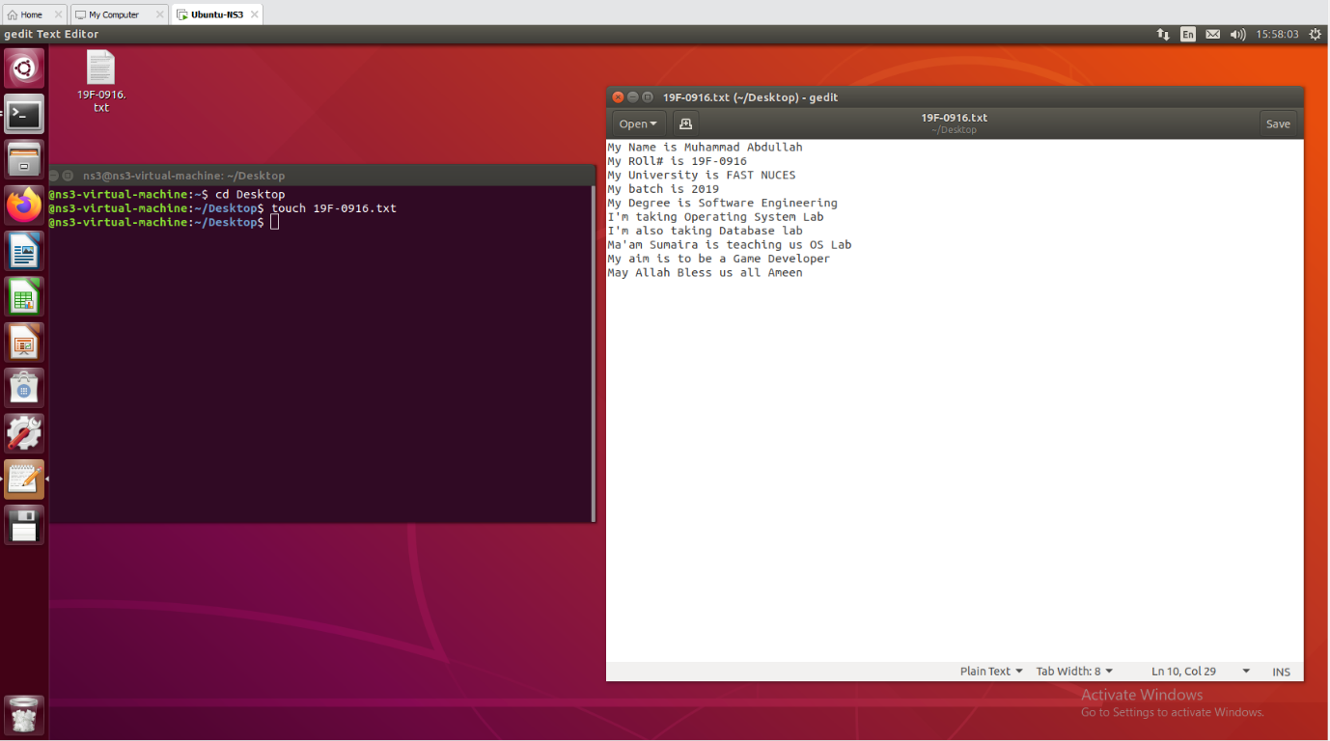

**MAKING FILE WITH NAME**

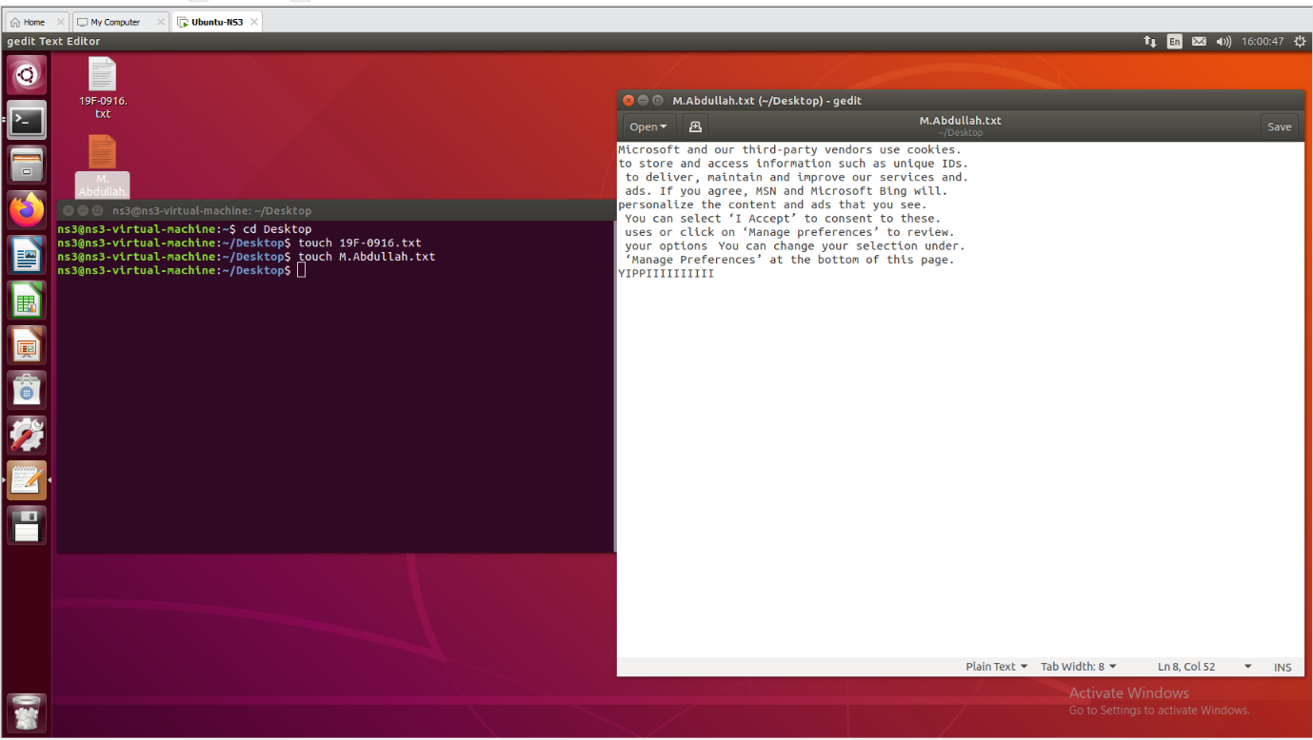

**CAT MERGED**

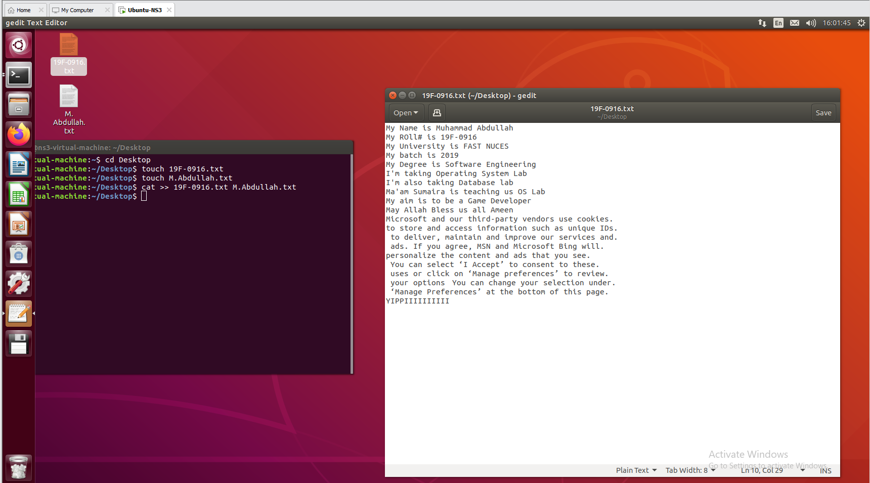

**OUTTPUTING FILE**

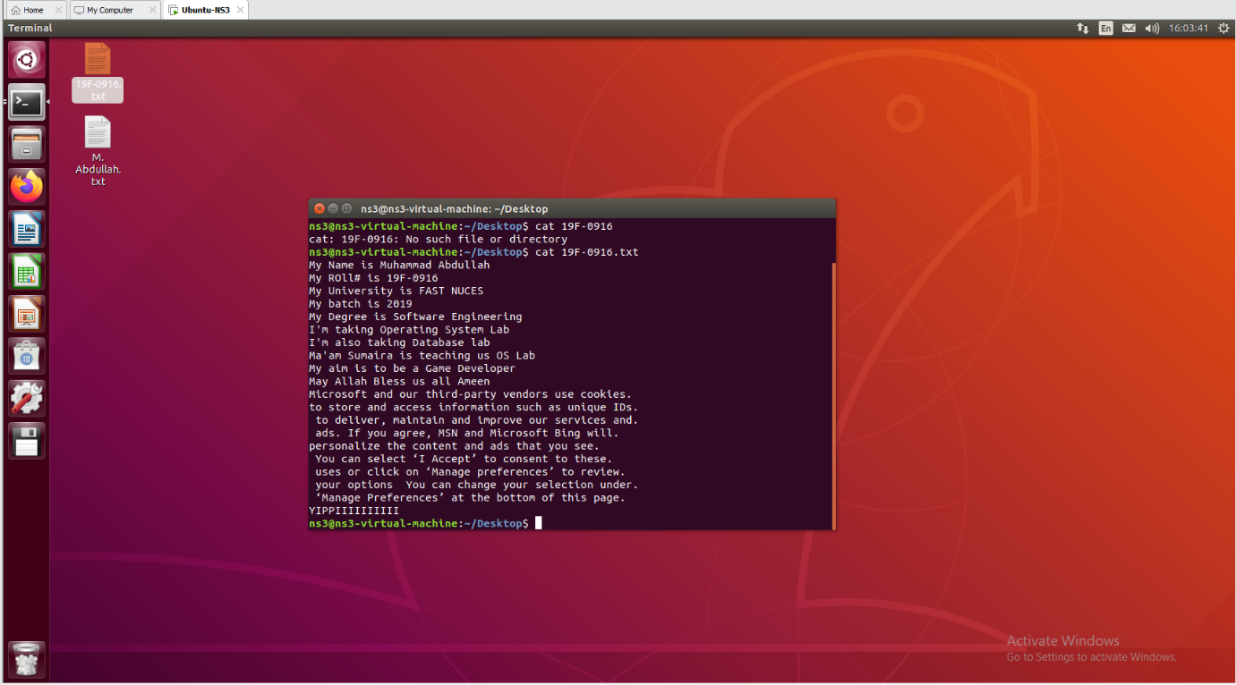

**MAKING NEW FILE BY OLD DATA**

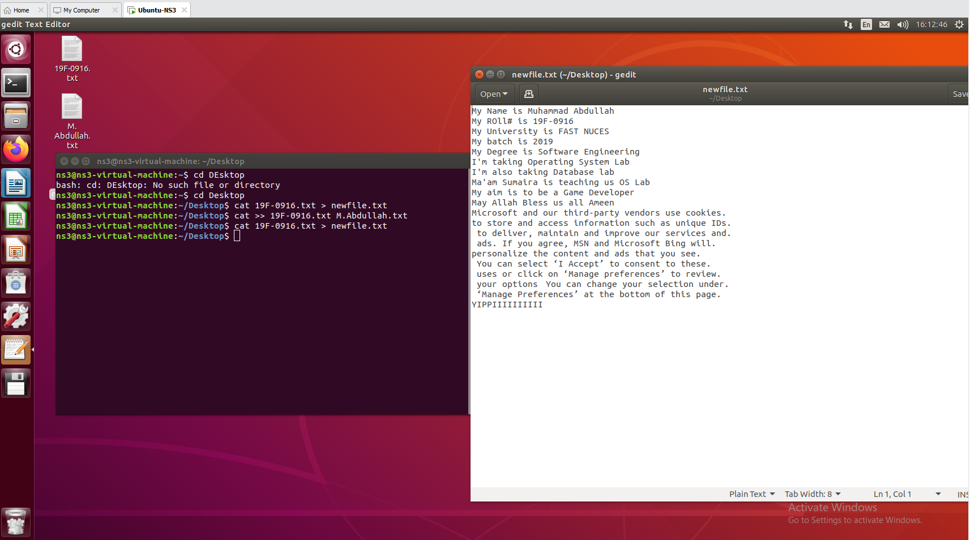

**SHOWING FIRST 2 LINES**

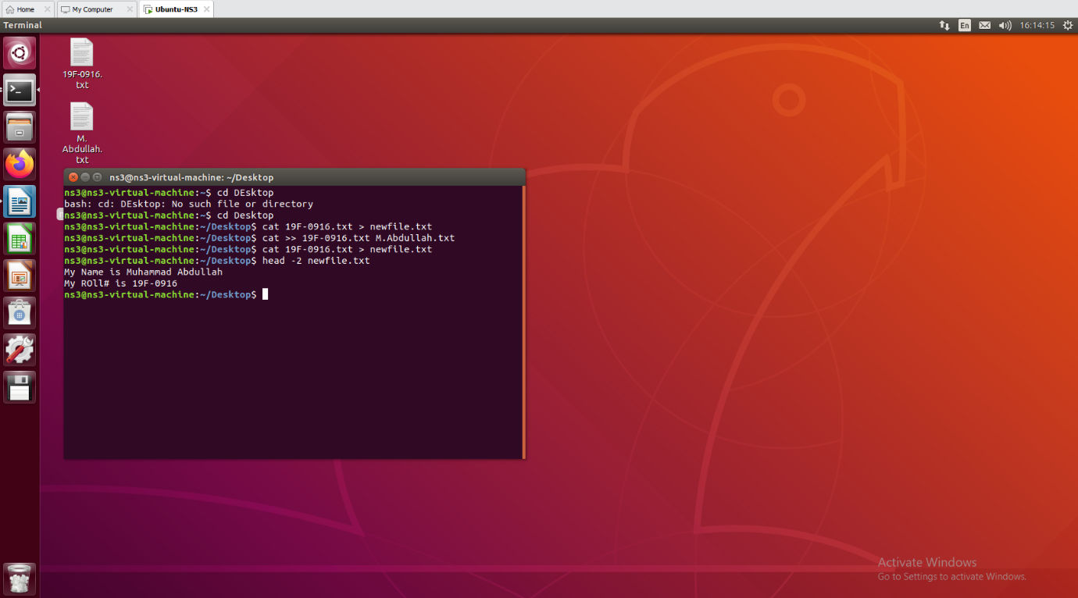

**SHOWING 2 LAST LINES**

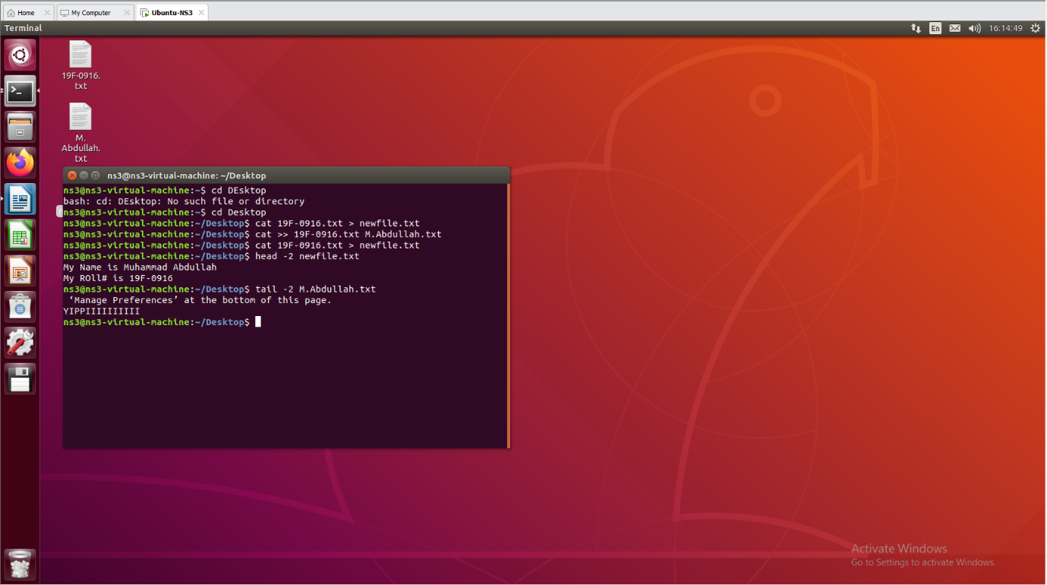

**SEARCHING ROLL#**

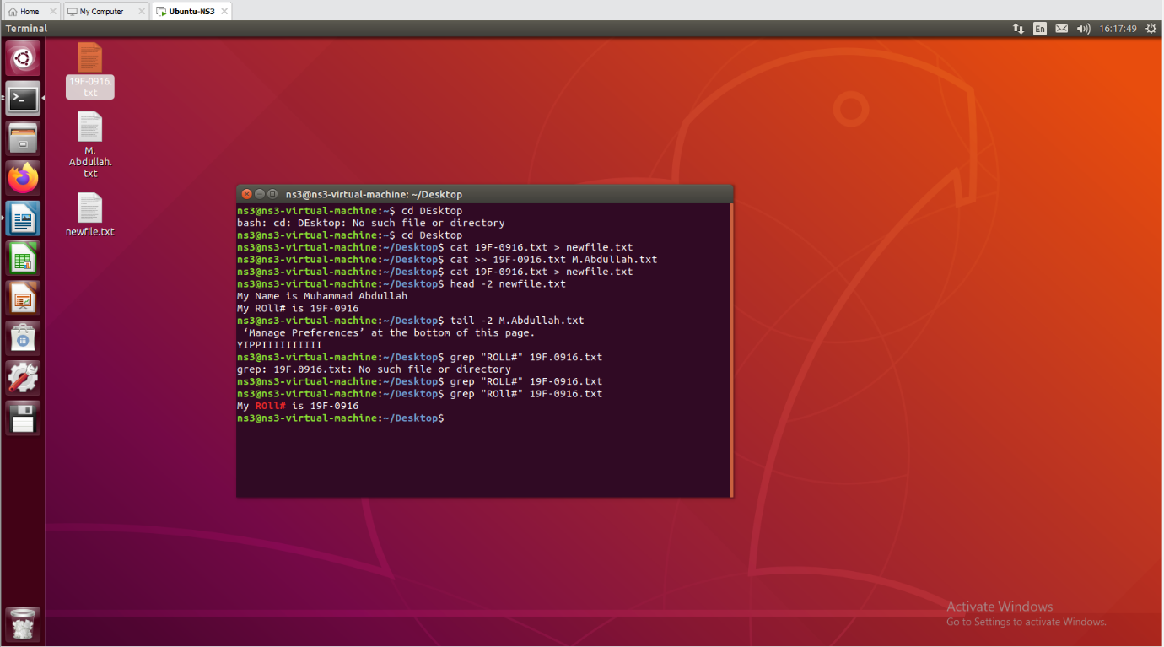

**GIVING PERMISSION FOR EXECUTE**

**REMOVING PERMSSION FOR WRITE**

**SHOWING TIME**

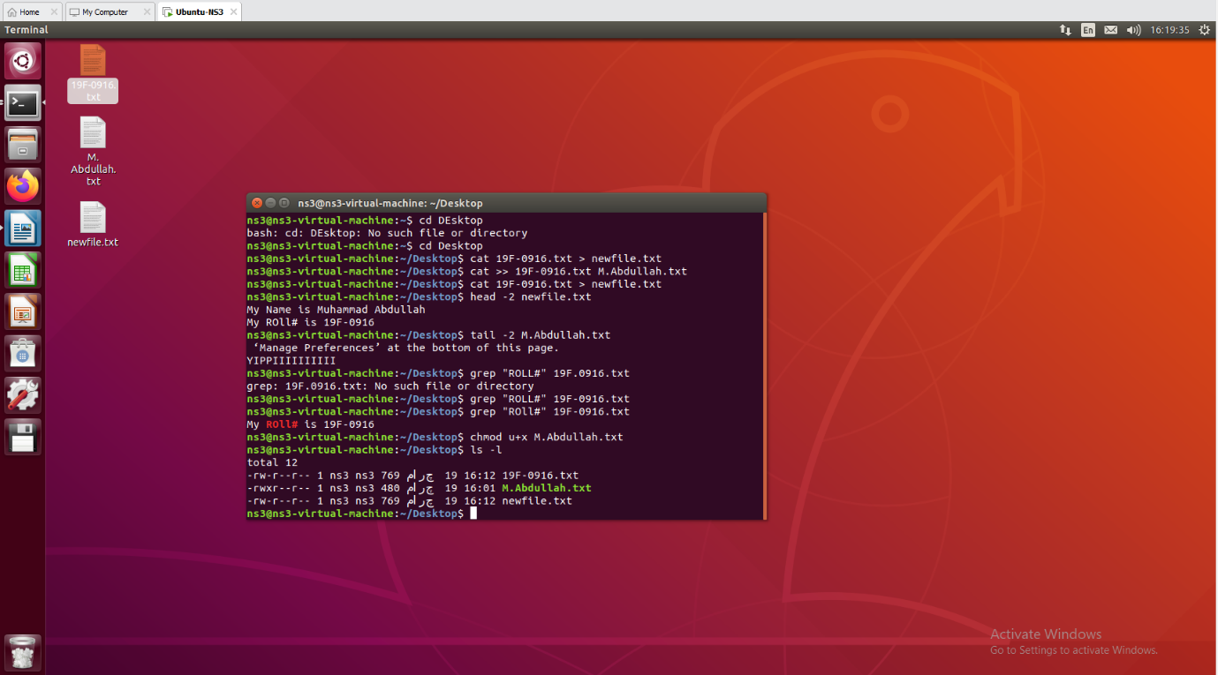

**SHOWING CURRENT LOCATION**

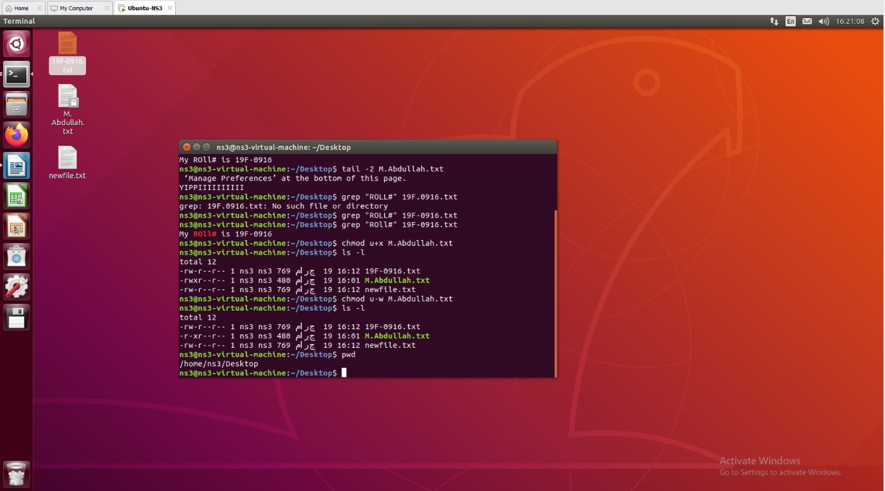

**MAKING NEW DIRECTORY**

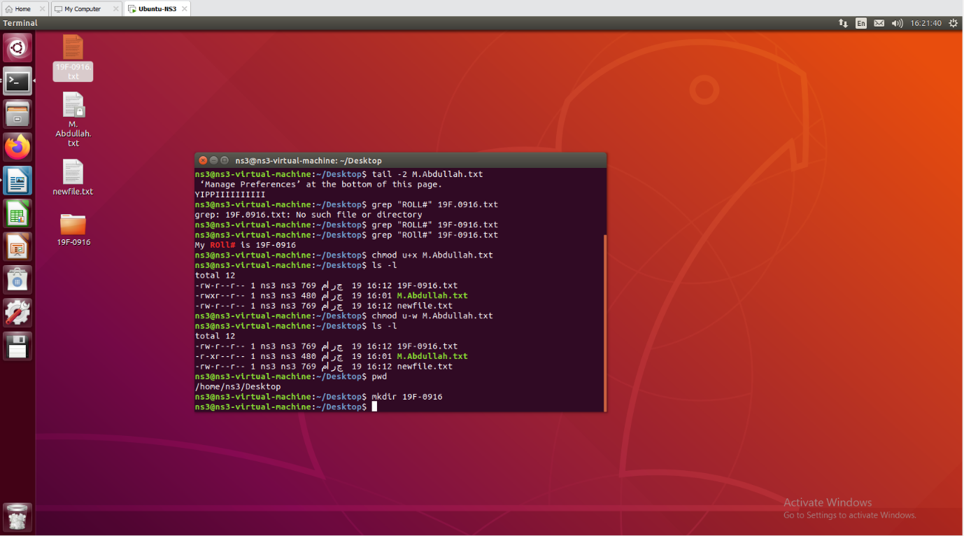

**ECHO THANK YOU**

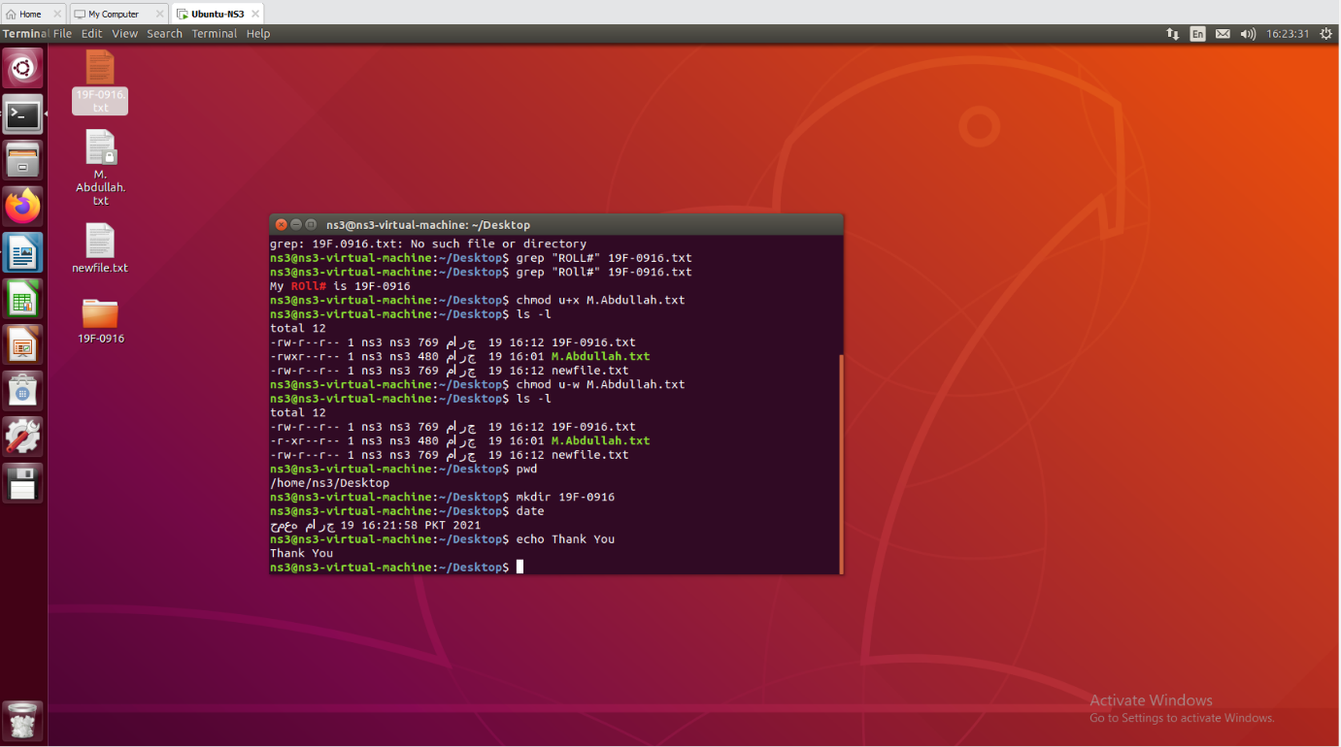

**COMPLETED**

**TASK 2**

**CREATING FILE AND ADDING DATA**

**NOW, PERFORMING MATHEMATICAL CALCULATIONS**

**Given = DECIMAL = BINARY**

**rwx = 4 + 2 + 1 = 7 = 111**

**r-x = 4 + 0 + 1 = 5 = 101**

**r-- = 4 + 0 + 0 = 4 = 100**

**FINAL:**

**111 101 100 = 7 5 4**

**USING 754 FOR PERMISSIONS**

**APPENDING ls COMMAND**

**COMPLETED**